**12. ReactJS-HOL**

**Implementation:**

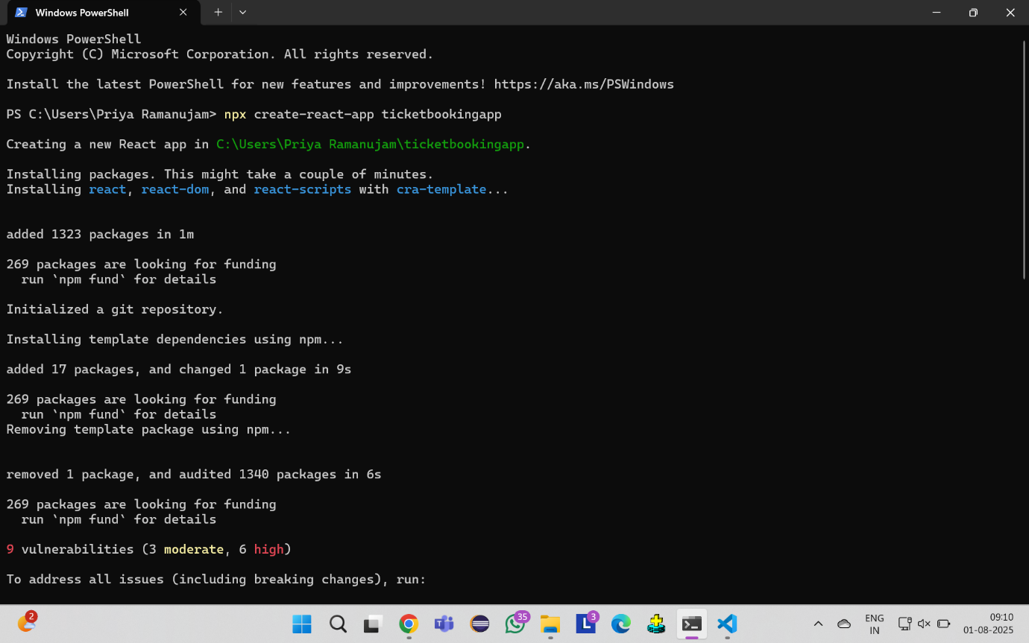

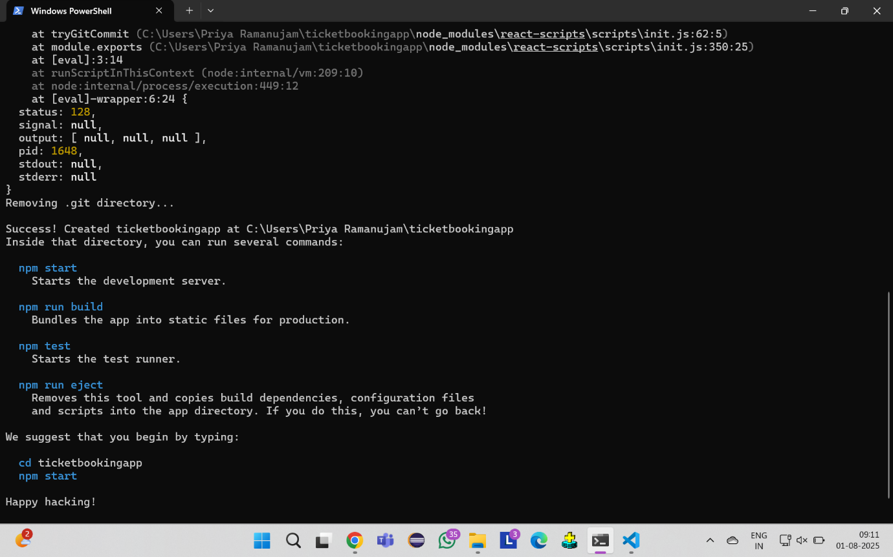

**App.js:**

import React, { useState } from 'react';

import './App.css';

function GuestPage() {

  return (

    <div className="page-container">

      <h2>Welcome, Guest!</h2>

      <div className="flight-details">

        <h3>Available Flights</h3>

        <div className="flight-card">

          <p><strong>Flight:</strong> AI 101</p>

          <p><strong>Route:</strong> Mumbai → Delhi</p>

          <p><strong>Departure:</strong> 10:00 AM</p>

          <p><strong>Arrival:</strong> 12:30 PM</p>

          <p><strong>Price:</strong> ₹5,500</p>

        </div>

        <div className="flight-card">

          <p><strong>Flight:</strong> 6E 202</p>

          <p><strong>Route:</strong> Delhi → Bangalore</p>

          <p><strong>Departure:</strong> 2:15 PM</p>

          <p><strong>Arrival:</strong> 5:00 PM</p>

          <p><strong>Price:</strong> ₹4,200</p>

        </div>

        <div className="flight-card">

          <p><strong>Flight:</strong> SG 303</p>

          <p><strong>Route:</strong> Chennai → Kolkata</p>

          <p><strong>Departure:</strong> 6:30 PM</p>

          <p><strong>Arrival:</strong> 8:45 PM</p>

          <p><strong>Price:</strong> ₹3,800</p>

        </div>

        <p className="login-message">Please login to book tickets!</p>

      </div>

    </div>

  );

}

function UserPage() {

  const [bookedFlights, setBookedFlights] = useState([]);

  const bookFlight = (flightName) => {

    if (!bookedFlights.includes(flightName)) {

      setBookedFlights([...bookedFlights, flightName]);

      alert(`Successfully booked ${flightName}!`);

    } else {

      alert(`You have already booked ${flightName}!`);

    }

  };

  return (

    <div className="page-container">

      <h2>Welcome, User!</h2>

      <div className="flight-details">

        <h3>Available Flights</h3>

        <div className="flight-card">

          <p><strong>Flight:</strong> AI 101</p>

          <p><strong>Route:</strong> Mumbai → Delhi</p>

          <p><strong>Departure:</strong> 10:00 AM</p>

          <p><strong>Arrival:</strong> 12:30 PM</p>

          <p><strong>Price:</strong> ₹5,500</p>

          <button

            className="book-btn"

            onClick={() => bookFlight('AI 101')}

            disabled={bookedFlights.includes('AI 101')}

          >

            {bookedFlights.includes('AI 101') ? 'Booked' : 'Book Now'}

          </button>

        </div>

        <div className="flight-card">

          <p><strong>Flight:</strong> 6E 202</p>

          <p><strong>Route:</strong> Delhi → Bangalore</p>

          <p><strong>Departure:</strong> 2:15 PM</p>

          <p><strong>Arrival:</strong> 5:00 PM</p>

          <p><strong>Price:</strong> ₹4,200</p>

          <button

            className="book-btn"

            onClick={() => bookFlight('6E 202')}

            disabled={bookedFlights.includes('6E 202')}

          >

            {bookedFlights.includes('6E 202') ? 'Booked' : 'Book Now'}

          </button>

        </div>

        <div className="flight-card">

          <p><strong>Flight:</strong> SG 303</p>

          <p><strong>Route:</strong> Chennai → Kolkata</p>

          <p><strong>Departure:</strong> 6:30 PM</p>

          <p><strong>Arrival:</strong> 8:45 PM</p>

          <p><strong>Price:</strong> ₹3,800</p>

          <button

            className="book-btn"

            onClick={() => bookFlight('SG 303')}

            disabled={bookedFlights.includes('SG 303')}

          >

            {bookedFlights.includes('SG 303') ? 'Booked' : 'Book Now'}

          </button>

        </div>

        {bookedFlights.length > 0 && (

          <div className="booked-flights">

            <h3>Your Booked Flights:</h3>

            <ul>

              {bookedFlights.map((flight, index) => (

                <li key={index}>{flight}</li>

              ))}

            </ul>

          </div>

        )}

      </div>

    </div>

  );

}

function App() {

  const [isLoggedIn, setIsLoggedIn] = useState(false);

  const handleLogin = () => {

    setIsLoggedIn(true);

  };

  const handleLogout = () => {

    setIsLoggedIn(false);

  };

  let pageContent;

  if (isLoggedIn) {

    pageContent = <UserPage />;

  } else {

    pageContent = <GuestPage />;

  }

  return (

    <div className="App">

      <header className="app-header">

        <h1>✈️ Ticket Booking App</h1>

        <div className="auth-buttons">

          {isLoggedIn ? (

            <button className="logout-btn" onClick={handleLogout}>

              Logout

            </button>

          ) : (

            <button className="login-btn" onClick={handleLogin}>

              Login

            </button>

          )}

        </div>

      </header>

      <main>

        {pageContent}

      </main>

    </div>

  );

}

export default App;

**App.css:**

.App {

  text-align: center;

  min-height: 100vh;

  background: linear-gradient(135deg, #667eea 0%, #764ba2 100%);

}

.app-header {

  background-color: rgba(255, 255, 255, 0.1);

  padding: 20px;

  display: flex;

  justify-content: space-between;

  align-items: center;

  backdrop-filter: blur(10px);

  box-shadow: 0 2px 10px rgba(0, 0, 0, 0.1);

}

.app-header h1 {

  color: white;

  margin: 0;

  font-size: 2.5rem;

  text-shadow: 2px 2px 4px rgba(0, 0, 0, 0.3);

}

.auth-buttons button {

  padding: 12px 24px;

  border: none;

  border-radius: 25px;

  font-size: 1rem;

  font-weight: bold;

  cursor: pointer;

  transition: all 0.3s ease;

  text-transform: uppercase;

  letter-spacing: 1px;

}

.login-btn {

  background: linear-gradient(45deg, #4CAF50, #45a049);

  color: white;

  box-shadow: 0 4px 15px rgba(76, 175, 80, 0.3);

}

.login-btn:hover {

  transform: translateY(-2px);

  box-shadow: 0 6px 20px rgba(76, 175, 80, 0.4);

}

.logout-btn {

  background: linear-gradient(45deg, #f44336, #d32f2f);

  color: white;

  box-shadow: 0 4px 15px rgba(244, 67, 54, 0.3);

}

.logout-btn:hover {

  transform: translateY(-2px);

  box-shadow: 0 6px 20px rgba(244, 67, 54, 0.4);

}

.page-container {

  padding: 40px 20px;

  max-width: 1200px;

  margin: 0 auto;

}

.page-container h2 {

  color: white;

  font-size: 2rem;

  margin-bottom: 30px;

  text-shadow: 2px 2px 4px rgba(0, 0, 0, 0.3);

}

.flight-details {

  background: rgba(255, 255, 255, 0.95);

  border-radius: 20px;

  padding: 30px;

  box-shadow: 0 10px 30px rgba(0, 0, 0, 0.2);

  backdrop-filter: blur(10px);

}

.flight-details h3 {

  color: #333;

  font-size: 1.8rem;

  margin-bottom: 30px;

  border-bottom: 3px solid #667eea;

  padding-bottom: 10px;

}

.flight-card {

  background: linear-gradient(135deg, #f5f7fa 0%, #c3cfe2 100%);

  border-radius: 15px;

  padding: 25px;

  margin: 20px 0;

  box-shadow: 0 5px 15px rgba(0, 0, 0, 0.1);

  transition: transform 0.3s ease, box-shadow 0.3s ease;

  position: relative;

}

.flight-card:hover {

  transform: translateY(-5px);

  box-shadow: 0 8px 25px rgba(0, 0, 0, 0.15);

}

.flight-card p {

  margin: 10px 0;

  font-size: 1.1rem;

  color: #333;

}

.flight-card strong {

  color: #667eea;

  font-weight: 600;

}

.book-btn {

  background: linear-gradient(45deg, #2196F3, #1976D2);

  color: white;

  border: none;

  padding: 12px 30px;

  border-radius: 25px;

  font-size: 1rem;

  font-weight: bold;

  cursor: pointer;

  margin-top: 15px;

  transition: all 0.3s ease;

  text-transform: uppercase;

  letter-spacing: 1px;

}

.book-btn:hover:not(:disabled) {

  transform: translateY(-2px);

  box-shadow: 0 5px 15px rgba(33, 150, 243, 0.4);

}

.book-btn:disabled {

  background: linear-gradient(45deg, #9E9E9E, #757575);

  cursor: not-allowed;

  opacity: 0.7;

}

.login-message {

  background: linear-gradient(45deg, #FF9800, #F57C00);

  color: white;

  padding: 15px;

  border-radius: 10px;

  font-size: 1.2rem;

  font-weight: bold;

  margin-top: 30px;

  text-shadow: 1px 1px 2px rgba(0, 0, 0, 0.3);

}

.booked-flights {

  background: linear-gradient(135deg, #E8F5E8, #C8E6C9);

  border-radius: 15px;

  padding: 25px;

  margin-top: 30px;

  border-left: 5px solid #4CAF50;

}

.booked-flights h3 {

  color: #2E7D32;

  margin-bottom: 15px;

  border-bottom: 2px solid #4CAF50;

}

.booked-flights ul {

  list-style: none;

  padding: 0;

}

.booked-flights li {

  background: rgba(76, 175, 80, 0.1);

  padding: 10px;

  margin: 8px 0;

  border-radius: 8px;

  color: #2E7D32;

  font-weight: bold;

  position: relative;

}

.booked-flights li::before {

  content: "✓";

  color: #4CAF50;

  font-weight: bold;

  margin-right: 10px;

}

@media (max-width: 768px) {

  .app-header {

    flex-direction: column;

    gap: 15px;

  }

  .app-header h1 {

    font-size: 2rem;

  }

   .page-container {

    padding: 20px 10px;

  }

   .flight-card {

    padding: 20px;

  }

}

